**LEEROY MAKACHIA’S SOCIAL MEDIA EXISTENCE**

**WHATSAPP**

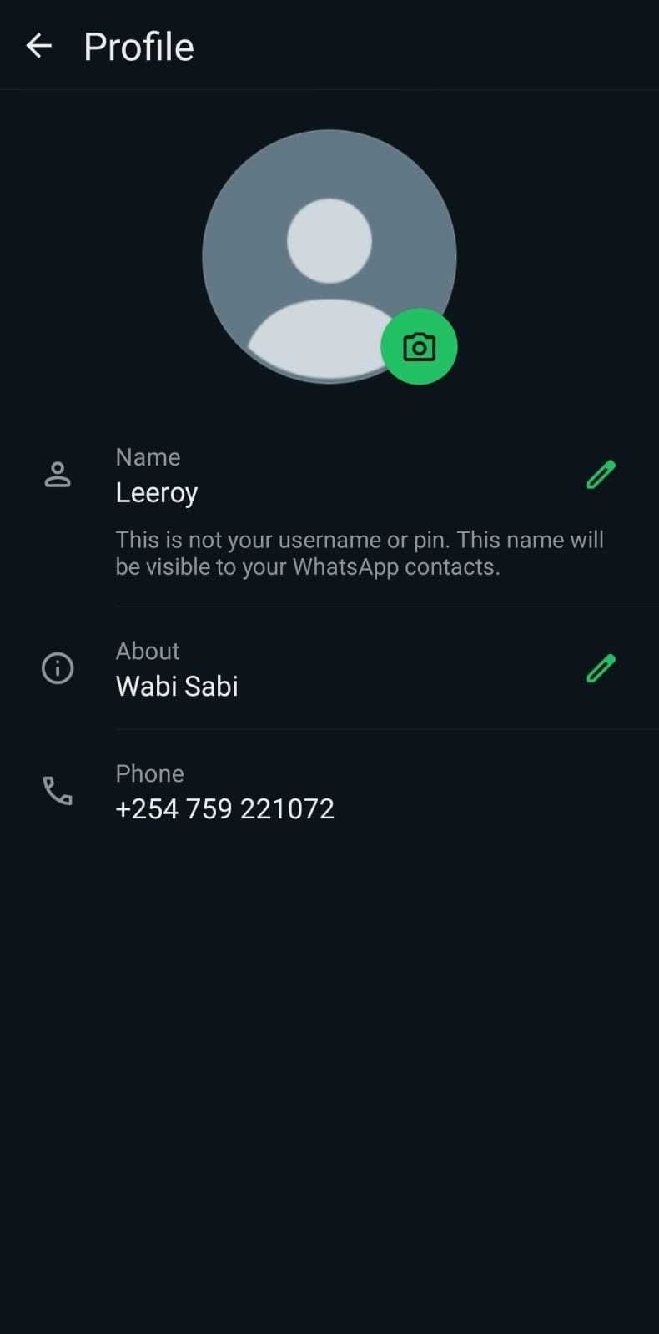

**X**

